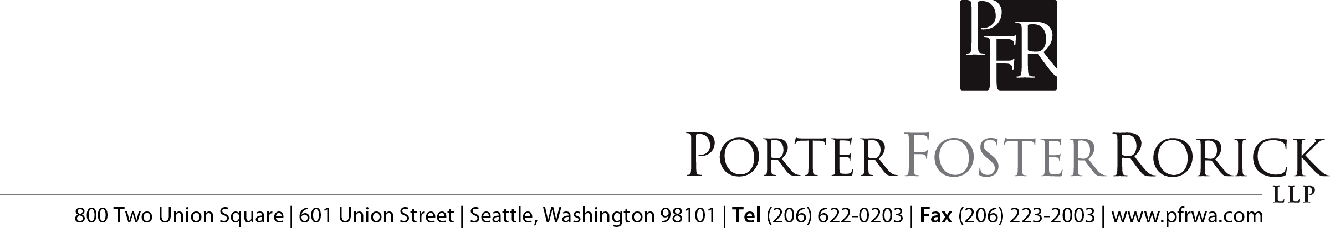
November 7, 2022

To | Michael Green | From | Lorraine Wilson

Re | SEIU Collective Bargaining Agreement

The following is a summary of the major points of the successor collective bargaining agreement between the District and SEIU, Local 925 (Service Employees International Union).
- The Agreement is for three years, through August 31, 2025. For 2022-23 wages were adjusted by the state inflationary factor (implicit price deflator, IPD, 5.5%) and market adjustments to keep salaries at or slightly above the median of comparison districts, or at least 2% above IPD. For the second and third years of the Agreement wages will be increased by the IPD, plus 0.75%, or 3.5%, whichever is greater. There were other adjustments to the structure of the wage schedule and classifications.
- Grievances are defined as alleged violations of the collective bargaining agreement, not state or federal law.
- Employee due process rights are more accurately defined.
- The nondiscrimination provision will mirror the protections of Washington state law.
- Provisions addressing union membership and employee information are further refined since the 2019 adjustments for the Janus decision prohibiting mandatory union fees.
- The status of temporary and substitute employees is corrected.
- The rights of bargaining unit applicants to information when not selected for a new position are described.
- Requirements when a swing or graveyard shift is moved earlier are restricted to permanent changes.
- Job share provisions are updated.
- Paraeducators will be provided with earlier notice of required training.
- Provisions for work during inclement weather are restructured for clarity.
- Application of seniority in awarding overtime or extra hours is aligned with other seniority provisions.
- Occasions for required Sunday work are clarified.
- Provision for an occasional maximum ten-day absence is added to the agreement.
- The Juneteenth holiday is added to the agreement.
- Provisions for requesting personal leave or being granted a leave of absence are clarified.
- The monthly VEBA contribution in lieu of the former insurance contribution is increased from $10 to $12.50.
- The operation of the steps of the wage schedule that are closed to new employees are clarified.
- Reimbursement for apprenticeship credits is increased from $60 to $75 per credit and the premium for completing an apprenticeship, or college equivalent, is increased from 60¢ to 75¢ per hour.
- Direct deposit is the only payroll option for employees.
- Individuals utilizing a second language in their positions will have their premium compensation increased from $1 to $1.10 per hour and pay for extra-hour translation or interpretation work will be at the employee’s time and one-half rate.
- The DSP paraeducator position is defined, and the pay rate established on the wage schedule.

